GeoRAMAN 2024

Instructions
- Please use preferably British English.
- Only abstracts submitted in accordance with this template will be considered (see page 2).
- All abstracts must be submitted before the deadline.
- Only two abstracts per registered person will be accepted.
- Save the file as a Word document (.doc or .docx).
- Submit the file via the online submission system.The file should be saved as: GeoRAMAN2024_SurnameName_Oral or Poster (the final type of presentation will be determined by the organising committee depending on the total number of presentations).

After submission, you should receive an automatic email confirming successful submission. If this is not the case and you need further assistance, please contact us at georaman2024@mail.ntua.gr

Title in Times New Roman (14 pt Bold) First Letters in Capital Form
First Author¹, Second Author², Third Author^{1,2}
(1) Institution, Address, Town, Country, Post code, Presenter (first author): email@address
(2) Institution, Address, Town, Country, Post Code.
________________________________________________________________________________

Extended Abstract
Please use this template to write your abstract. The abstracts should not be longer than two A4 pages (6700 characters with spaces). Use Times New Roman, 11 pt. as the default font. Single line spacing, justified. All figures, diagrams (Fig. 1). and tables (Table 1) should be included in the text. should be included in the text. It must not contain more than two figures/tables. The content should clearly state the background and objectives, methods used, results, conclusions, and key words. Please use a 0.5 cm indent for the first line of each paragraph

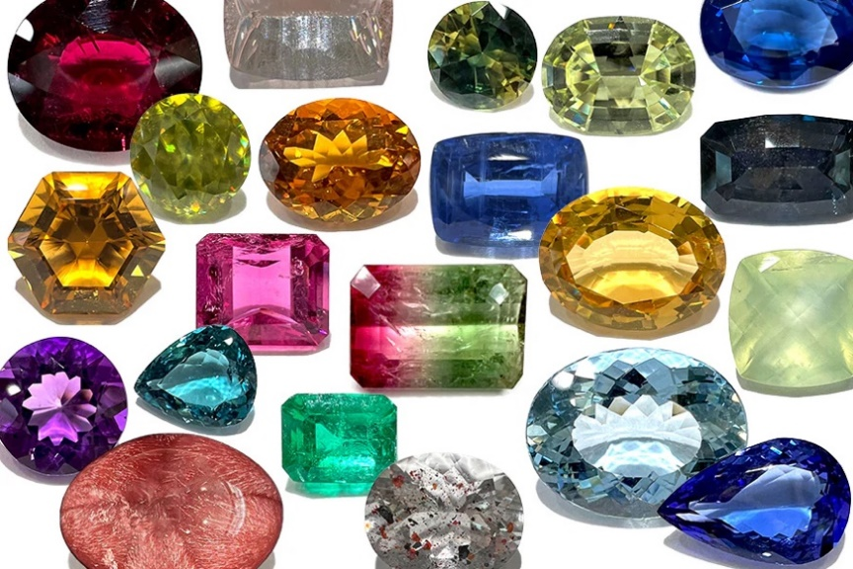
Figure 1. Example of an image (300 dpi) and caption (Times New Roman 10 pt. Italics).

Table 1. Example of a table and caption (Times New Roman 10 pt. Italics). Please do not forget to add 1 blank line after the Table.
TITLE 1 | TITLE 2 | TITLE 3 | TITLE 4
Name | 0.00 | 0.00 | 0.00
Name | 0.00 | 0.00 | 0.00
Name | 0.00 | 0.00 | 0.00

The sections for acknowledgements and references should be placed at the end of the abstract (Times New Roman 10 pt.). Leave one line blank before the section headings. All publications cited in the text should be included in the list of references. The references should be cited with numbers in the text and listed at the end of the paper in the order in which they appear in the text. It would be easier to use a reference management software such as Zotero or Mendeley and use the citation style used in the Journal of Raman Spectroscopy. A maximum of 10 references is recommended.

Keywords
Please write 3-8 keywords or phrases of your study, Times New Roman, 10 pt

Acknowledgements
Remember to thank those who have supported you and your work. Use Times New Roman 10 pt. Thank you for reading the instructions. Please feel free to contact us for further information.

References
[1] P. Vandenabeele, L. Moens, H.G.M. Edwards, R. Dams, J. Raman Spectrosc. 2000, 31, 509.
(example for Journals)
[2] B. Guineau, V. Guichard, ICOM Committe for Conservation: 8th Triennial Meeting, Sydney, Australia, 6-11 September, 1987, Preprints, vol. 2. The Getty Conservation Institute: Mrina del Rey, CA, 1987, p. 659. (example for Symposium)
[3] H. Schweppe, H. Roosen-Runge, Artists’ Pigments. A handbook of their History and Characteristics, vol. 1 Oxford University Press: New York, 1996, p. 255. (example for Books)

